The Online Clothing Store Database Project

Developed by: Alaa El Hajjar

Date of Submission: May 16th, 2024

- Project Proposal

My client has an online clothing business. He sells clothing using Poshmark. Poshmark allows the seller to operate fully using the app. My client purchases items for a discounted price, and then uploads it to Poshmark to sell it for profit. He can set the price that he desires, and once a customer buys the item, Poshmark will automatically create a shipping label. The only thing my client must do after is to ship it through postal services. As great and convenient as Poshmark makes it for the seller, a key element remains missing. My client is not able to track trending products, their trending attributes and the profit he makes. Since Poshmark doesn’t take into account the cost of the clothing item that my client had to spend, I will be creating a database that would address that.

My database model will focus on getting the answers my client wants. It will focus on tracking profits and the characteristics of clothing items that provide the most profit. It will keep track of what sells the most from the brand, color, size, category (men, women) that are associated with that item. Overall, the database would allow my client to track his profit and provide him insight on what clothing trends are the most profitable.

- UML Relational Model

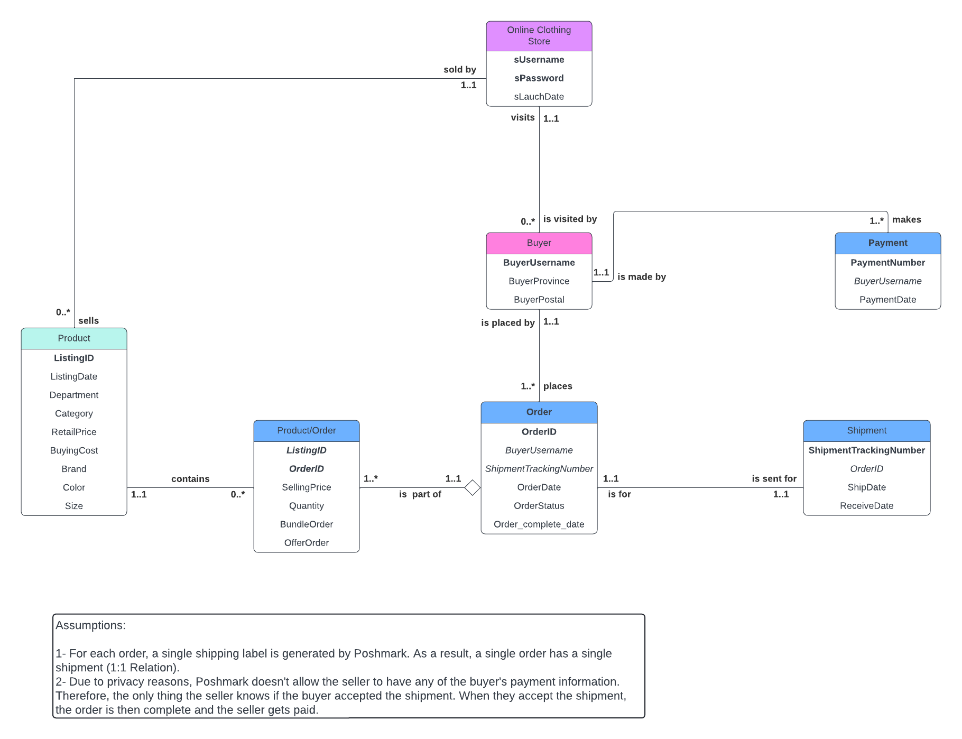

- Normalization

BuyerUsername | BuyerProvince | BuyerPostal
lovepacking | ON | N2H 0B2
sociallibra | ON | M4M 0C5
erivera744 | ON | N6B 1X5
ghermaann | QC | J6J 6E6
alinjay7791 | NS | B3A 4A3
faridasaher | AB | T2G 2Y3
sophiah517 | ON | K7L 3X5
theoneoli | AB | T1L 1B6

Buyer(BuyerUsername, BuyerProvince, BuyerPostal)

FD1: BuyerUsername> BuyerProvince, BuyerPostal
UNF? Yes, no multi-value fields
1nf? Yes, no duplicate attributes, no nulls, and can move records around freely
2nf? Yes, no composite key, as a result, there are no nonkey attributes that are partially dependent on a portion of the key.
3nf? Yes, no nonkey attributes determine another nonkey attribute

OrderID | OrderDate | OrderStatus | Order_complete_date | ShipmentTrackingNumber | BuyerUsername
6585d6b81e017de2fc197333 | 12/22/23 | Accepted | 12/29/2023 | 1026167021881737 | lovepacking
658b8b4bd74b0f9d5868bf98 | 12/27/23 | Accepted | 1/2/2024 | 1026167136551730 | sociallibra
658b6a8fd74b0fcb6f53baff | 12/26/23 | Accepted | 1/2/2024 | 1026167111007733 | erivera744
65876c6db142f35a094bcef4 | 12/23/23 | Accepted | 1/2/2024 | 1026167048548736 | ghermaann
658bad20ef1ef765f3c14d34 | 12/26/23 | Accepted | 1/5/2024 | 1026167113610733 | alinjay7791
5d4c1c80ba97fefea2dc493f | 1/7/24 | Accepted | 1/11/2024 | 1026167670236735 | faridasaher
6599570357357c7be17a6582 | 1/6/24 | Accepted | 1/15/2024 | 1026167645613738 | sophiah517
65a264eebee4b09dd9154671 | 1/13/24 | Accepted | 1/18/2024 | 1026167973238733 | theoneoli

Order(OrderID, OrderDate, OrderStatus, Order_complete_date, ShipmentTrackingNumber, BuyerUsername)

FD1: OrderID> OrderDate, OrderStatus, Order_complete_date, ShipmentTrackingNumber, BuyerUsername
UNF? Yes, no multi-value fields
1nf? Yes, no duplicate attributes, no nulls, and can move records around freely
2nf? Yes, no composite key, as a result, there are no nonkey attributes that are partially dependent on a portion of the key.
3nf? Yes, no nonkey attributes determine another nonkey attribute

Assumption: There is no dependencies between ShipmentTrackingNumber and BuyerUsername because a buyer can make repeated orders. As a result, different ShipmentTrackingNumber can have the same BuyerUsername if we added more data.

ListingID | LisitngDate | Department | Category | Brand | Color | Size | BuyingCost | RetailPrice
1 | 12/1/23 | Women | Hats | Coach | White | S | $30 | $48.00
2 | 12/27/23 | Men | Hats | Polo by Ralph Lauren | Blue | S | $19 | $30.00
3 | 12/26/23 | Men | Hats | Polo by Ralph Lauren | Green-Blue | S | $19 | $32.00
4 | 12/15/23 | Men | Hats | Polo by Ralph Lauren | Gray | S | $19 | $65.00
5 | 12/26/23 | Men | Sweatshirts and Hoodies | Polo by Ralph Lauren | Red-Blue | L | $50 | $129.00
6 | 1/7/24 | Men | Hats | Polo by Ralph Lauren | Blue | S | $19 | $35.00
7 | 1/6/24 | Men | Shirts | Polo by Ralph Lauren | Gray | M | $20 | $43.00
8 | 10/6/23 | Men | Suits | Topman | Blue | 42R | $10 | $38.00

Product(ListingID, ListingDate, Department, Category, Brand, Color, Size, BuyingCost, RetailPrice)

FD1: ListingID> ListingDate, Department, Category, Brand, Color, Size, BuyingCost, RetailPrice
UNF? Yes, no multi-value fields
1nf? Yes, no duplicate attributes, no nulls, and can move records around freely
2nf? Yes, no composite key, as a result, there are no nonkey attributes that are partially dependent on a portion of the key.
3nf? Yes, no nonkey attributes determine another nonkey attribute

ListingID | OrderID | SellingPrice | Quantity | BundleOrder | OfferOrder
1 | 6585d6b81e017de2fc197333 | $48.00 | 1 | N | N
2 | 658b8b4bd74b0f9d5868bf98 | $30.00 | 1 | N | Y
3 | 658b6a8fd74b0fcb6f53baff | $32.00 | 1 | N | N
4 | 65876c6db142f35a094bcef4 | $65.00 | 1 | N | N
5 | 658bad20ef1ef765f3c14d34 | $129.00 | 1 | N | N
6 | 5d4c1c80ba97fefea2dc493f | $35.00 | 1 | N | N
7 | 6599570357357c7be17a6582 | $43.00 | 1 | N | N
8 | 65a264eebee4b09dd9154671 | $38.00 | 1 | N | N

Product/Order(ListingID, OrderID, SellingPrice, Quantity, BundleOrder, OfferOrder)

FD1: ListingID, OrderID > SellingPrice, Quantity, BundleOrder, OfferOrder
UNF? Yes, no multi-value fields
1nf? Yes, no duplicate attributes, no nulls, and can move records around freely
2nf? Yes, there are no nonkey attributes that are partially dependent on a portion of the key.
3nf? Yes, no nonkey attributes determine another nonkey attribute

ShipmentTrackingNumber | ShipDate | ReceiveDate | OrderID
1026167021881737 | 12/22/2023 | 12/29/2023 | 6585d6b81e017de2fc197333
1026167136551730 | 12/27/2023 | 1/2/2024 | 658b8b4bd74b0f9d5868bf98
1026167111007733 | 12/27/2023 | 1/2/2024 | 658b6a8fd74b0fcb6f53baff
1026167048548736 | 12/27/2023 | 1/2/2024 | 65876c6db142f35a094bcef4
1026167113610733 | 12/27/2023 | 1/5/2024 | 658bad20ef1ef765f3c14d34
1026167670236735 | 1/10/2024 | 1/11/2024 | 5d4c1c80ba97fefea2dc493f
1026167645613738 | 1/9/2024 | 1/15/2024 | 6599570357357c7be17a6582
1026167973238733 | 1/15/2024 | 1/18/2024 | 65a264eebee4b09dd9154671

Shipment(ShipmentTrackingNumber, ShipDate, ReceiveDate, OrderID)

FD1: ShipmentTrackingNumber> ShipDate, ReceiveDate, OrderID
UNF? Yes, no multi-value fields
1nf? Yes, no duplicate attributes, no nulls, and can move records around freely
2nf? Yes, no composite key, as a result, there are no nonkey attributes that are partially dependent on a portion of the key.
3nf? Yes, no nonkey attributes determine another nonkey attribute

PaymentNumber | PaymentDate | BuyerUsername
6585d6b81e017de2fc197333-122923 | 12/29/2023 | lovepacking
658b8b4bd74b0f9d5868bf98-010224 | 1/2/2024 | sociallibra
658b6a8fd74b0fcb6f53baff-010224 | 1/2/2024 | erivera744
65876c6db142f35a094bcef4-010224 | 1/2/2024 | ghermaann
658bad20ef1ef765f3c14d34-010524 | 1/5/2024 | alinjay7791
5d4c1c80ba97fefea2dc493f-011124 | 1/11/2024 | faridasaher
6599570357357c7be17a6582-011524 | 1/15/2024 | sophiah517
65a264eebee4b09dd9154671-011824 | 1/18/2024 | theoneoli

Payment(PaymentNumber, PaymentDate, BuyerUsername)

FD1: PaymentNumber > PaymentDate, BuyerUsername,
UNF? Yes, no multi-value fields
1nf? Yes, no duplicate attributes, no nulls, and can move records around freely
2nf? Yes, no composite key, as a result, there are no nonkey attributes that are partially dependent on a portion of the key.
3nf? Yes, no nonkey attributes determine another nonkey attribute

Assumption: There is no dependencies between PaymentDate and BuyerUsername because a buyer can make repeated orders, which have their unique PaymentDate. As a result, different PaymentDate can have the same BuyerUsername if we added more data.

sUsername | sPassword | sLaunchDate
@mosdb | ###### | 12/30/2022

OnlineClothingStore(sUsername, sPassword, sLauchDate)

FD1: sUsername, sPassword> sLauchDate
UNF? Yes, no multi-value fields
1nf? Yes, no duplicate attributes, no nulls, and can move records around freely
2nf? Yes, there are no nonkey attributes that are partially dependent on a portion of the key.
3nf? Yes, no nonkey attributes determine another nonkey attribute

Assumption: To know the sLaunchDate ( which is store launch date), you need what identifies the online Poshmark store, which is username and password combined.

Remark: Password is listed as ###### as it is confidential information

- 3NF Normalized Model

The Model is still the same as Part II. As no tables require further normalization. Model:


- DML Questions

- List Buyer Province and postal for each buyer
- List the username of every buyer who lives in Ontario
- List the ID for every clothing item that retails for more than $50
- List the ID for every product in size small or large
- How much did the Online Store pay in advance on all the clothing items? ( Asking for total Buying Cost)
- How many hats were listed in each Department?
- How many Blue colored hats were sold in each Department?
- What is the selling price for each item shipped in January 2024?
- What is the total profit made by the seller?
- What is the total profit made by the seller on each product?
- How does each color sell? Rank best to least
- What Brand sells the most?
- How many orders were shipped to Alberta (AB)?

- Log Sheet

- Project Proposal
-Date: April 13, 2024
-Participants: My Client and I
-Issue/Meeting: I talked to my client (my friend) and we discussed what he needs for his Poshmark Online Store. He discussed what he would like to see in the reports and that’s what I based the requirements on.

- UML Relational Model
-Date: April 20-22, 2024
-Participant: My Client and I
-Issue/Meeting: This part was pretty straightforward for me as my client has excel data sheets/reports that he gets from Poshmark. In these reports, there was almost all the data that I needed for a clear break down of the features of these clothing items. This helped me a lot in structuring my attributes. I had to do some phone calls with my client to ask about logistical information concerning shipment and payment. He clarified to me that when the buyer accepts the shipment, he gets paid. This all allowed me to create the right multiplicity and, as a result, a clear UML Relational Model.

- 3 NF Normalized Model
-Date: April 30, 2024-May 3, 2024
-Participant: Me
-Issue/Meeting: During this process, I had to contact my client to get more data as I needed it to do normalization. After having all the proper data, I was ready to start normalization. This part was a little challenging as I was unsure of my normalized tables. However, I met with you, professor, to discuss all my normalized tables, the thought process, and to get verification that it was all correct. After we met and all the normalized tables were correct, I did not need to further develop the model . The 3NF normalized model was ready. Finally, I was ready to physically implement the database using Microsoft Access.

- DDL

-Date: May 6, 2024- May 10, 2024
-Participant: Me
-Issue/Meeting: DDL was a little challenging with building the tables for the 1:1 relationship between SHIPMENT and ORDER table. It was complicated as Access wasn’t recognizing that relationship. At first, I decided to create the 2 tables without their respective FKs (ShipmentTrackingNumber and OrderID) and then manually add them. That was all okay until I started entering data in. As I was almost done with entering all the data in the tables, I got an error with the SHIPMENT table. I was getting ‘mismatch in data’ error. I then deleted the tables, re-did them again many times, entered the data multiple times. However, the error persists. I then decided that the only way for me to have the data in SHIPMENT table without getting an error, is to disable referential integrity. Now that I have all the data in and by having the FK attributes in both tables ( even though they don’t have referential integrity), I am able to run queries.

- DML
-Date: May 15, 2024
-Participant: Me
-Issue/Meeting: DML was a breeze compared to the DDL issue with the one-to-one relationship. I found it easy and enjoyable to run queries. I learned a lot and that was very beneficial for the final preparation.

